

Structural Design

(Inside View)

**Vertical corrugation**

 65*/*8  Design#:

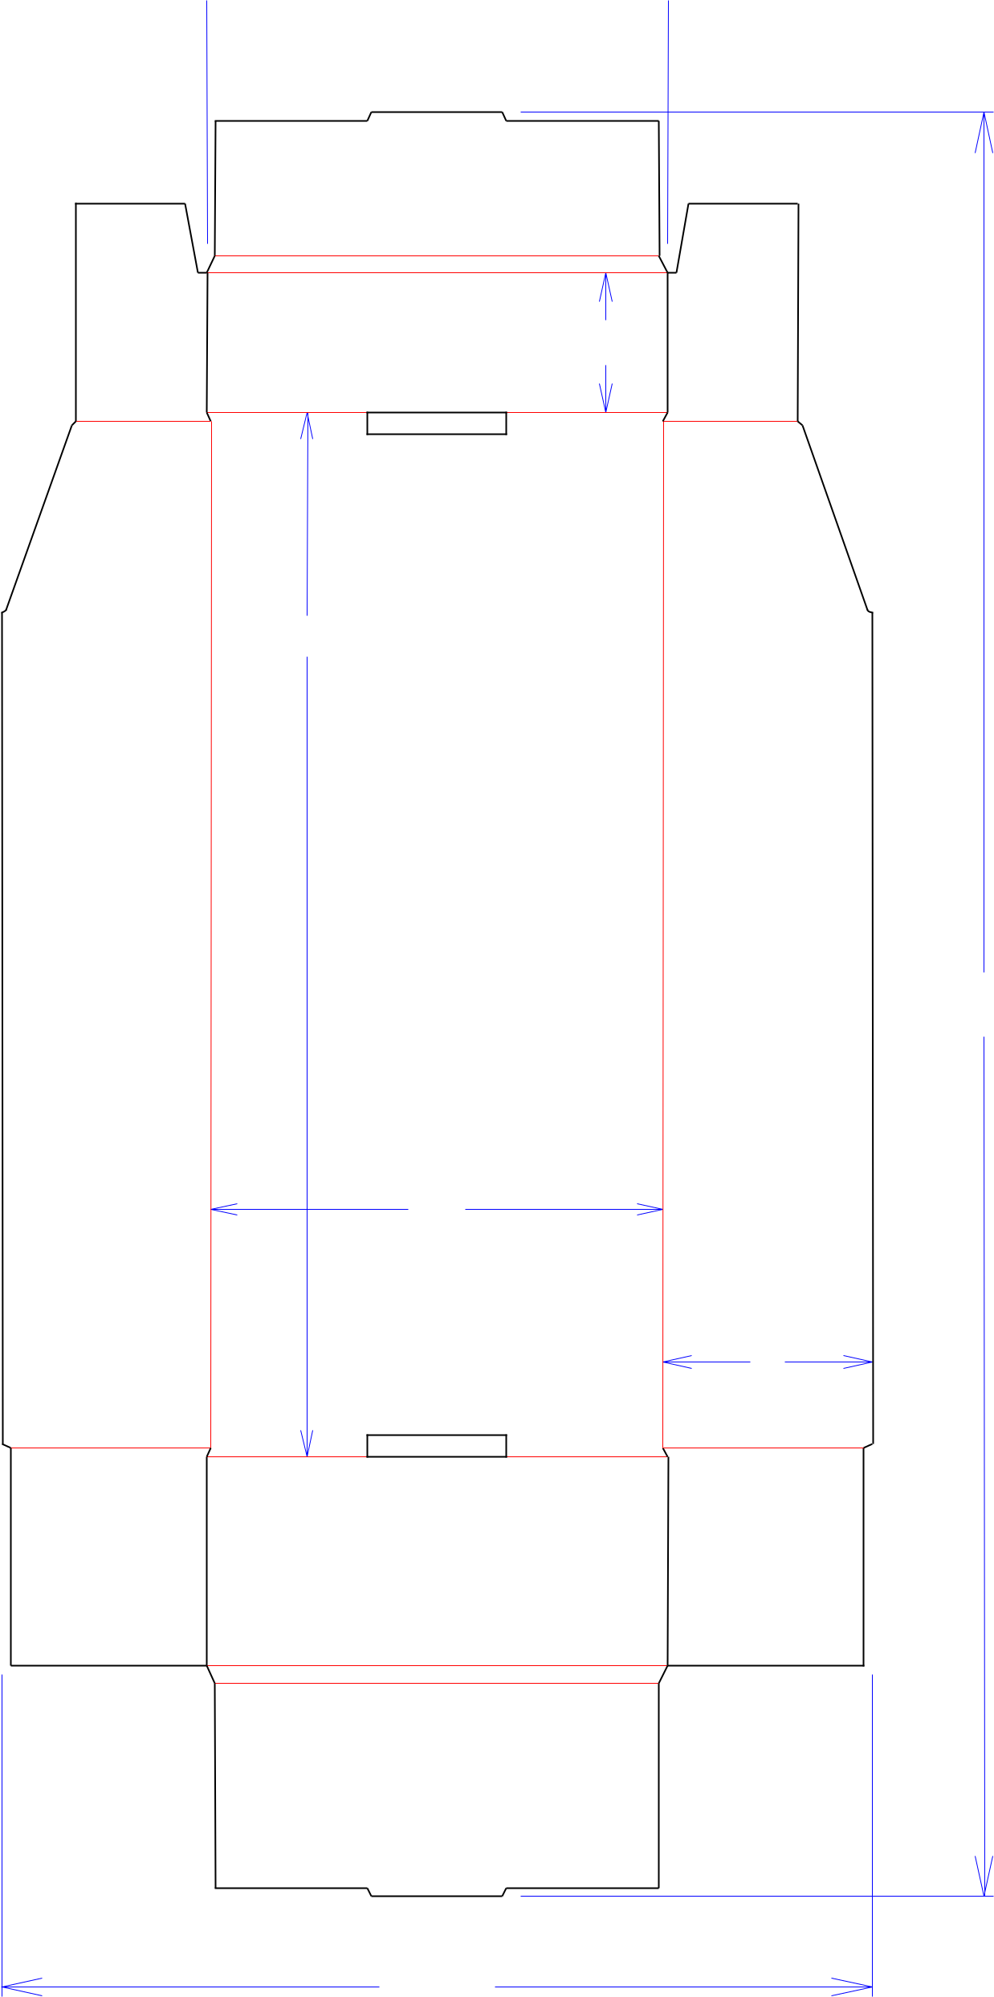

2

15

255*/*8

61*/*2

3

121*/*2



Cut Crease Crease with Matrix Cut Crease Half Knife Cut Tear Tape Perforation



**190110-01**

Customer:

**DeMet's Candy**

Description:

**Tray -Shelf Ready TURTLES 17.5 oz Club Bag**

**SINGLE-OUT DRAWING**

Qty/Unit:

Style: **NJDC**

Board: **32BW**

Combination: **36MW - 23M - 35HP**

I.D. : **14+3/8 x 6+3/8 x 3**

Area of Blank - Waste : **1.94 sq. ft.**

Waste on Blank : **13.01%**

Finished Piece Weight: **0.20 lbs./91.80g**

Over-all Blank: **25+5/8 x 12+1/2**

Notes:

Revision Info: **[0] 02/06/2019**

Designer: **Alan Groff**

Designright and Copyright of DS Smith Corrugated Packaging Ltd. This technical Specification is subject to Manufacturing tolerances. Drawing dimensions shown are crease to crease. Date printed: 02/06/2019